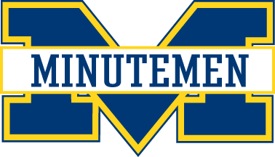
Minutemen Coaching Requirements
WHAT | WHO
PA State background checks  http://www.vfminutemen.com/page/show/1119374-manager-resources | Coaches  Assistant Coaches  Managers
Safe Sport Certificate: Coaches and Assistant Coaches –  http://www.usahockey.com/page/show/908023-usa-hockey-safesport-program | Coaches  Assistant Coaches  Managers
Coaching Certification: Coaches and Assistant Coaches - http://www.usahockey.com/coachingclinics | Coaches  Assistant Coaches
Coaching Modules: Coaches and Assistant Coaches –  If a coach is coaching at a different level for the first time, this MUST be completed) http://www.usahockey.com/page/show/892966-age-specific-modules | Coaches  Assistant Coaches

